‘The Trouble With Being Born’: Film Review

Striking intellectualism and icy formalism vie with a viscerally upsetting premise in Sandra Wollner's deeply fraught sci-fi provocation.
By Jessica Kiang
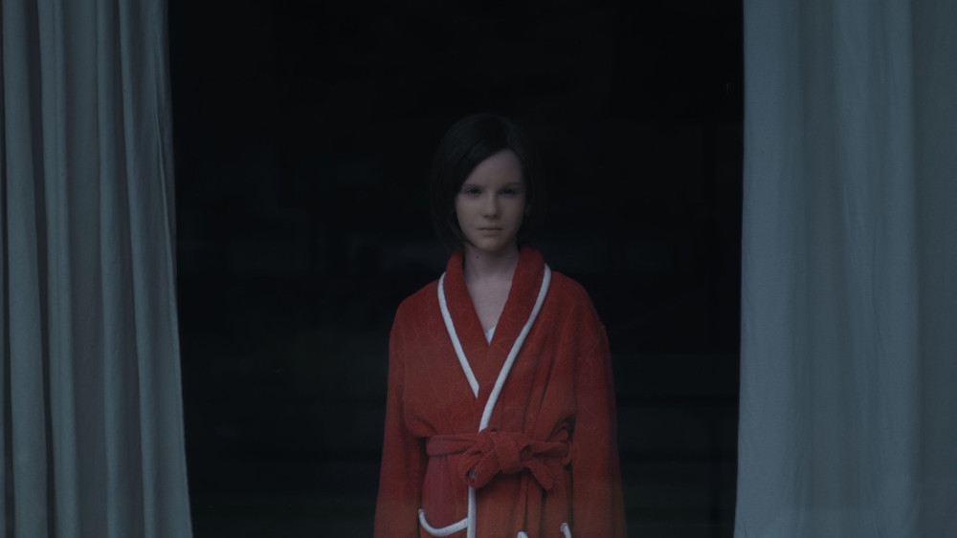
CREDIT: Courtesy of Berlin Film Festival
Director:
Sandra Wollner
With:
Lena Watson, Dominik Warta, Ingrid Burkhard, Jana McKinnon
Running time: 93 MIN.
It’s a strange feeling to be among the earliest audiences — and who can tell just how many more such a disturbing, hard-sell film will reach — for a project destined for notoriety. But then Sandra Wollner’s “The Trouble With Being Born” inspires nothing but strange feelings, from unnerving horror to shocked admiration to visceral disgust to that specific type of disorienting nausea that comes from the fractional delay between your eye processing a well-composed image, and your brain comprehending the implications of the actions so coolly depicted.
That gap is just one of the many conceptual fissures into which Wollner’s desperately creepy, queasy, thought-provoking film gnaws: image vs. implication; human vs. non-human; real vs. unreal. If “The Trouble With Being Born” lives anywhere, it is in a house in a forest on the deepest, most sunless lower slopes of the uncanny valley.
Indecipherable, abstract, staticky images flicker and jiggle, while a glitchy digitized noise finally coalesces into a voice. It’s a child’s voice occasionally edged with auto-tuned artificiality, recounting the memory of a childhood summer’s day spent with her Papa. We turn a corner in a wood and are suddenly beside a backyard pool and watching that very day play out.
The trigger warning big enough to cover the plot details, let alone the themes here, has not yet been invented (such a trigger would have to be more in the order of the firing pin on a mortar, or maybe the detonation code to a suitcase nuke), so proceed with caution: The child is not a child but a robot called Ellie, played by 10-year-old Lena Watson (which is a pseudonym to protect the privacy of the underage actress, who also wears a features-blurring plastic face mask).
Her machine nature we understand when “Papa” (Dominik Warta) finds her floating face down in the pool and reacts with a slightly resigned “not again,” rather than with panic, before carrying Elli back into the house and “rebooting” her via his phone. And soon we come to realize, in dispassionately shot scenes that accrue a sinking dread in the details of a touch that lingers too long, or a kiss that cannot be interpreted as paternal, that the relationship between Elli and “Papa” is sexual in nature.
This example of techno-pedophilia comes to us with wires crossed and synapses shorting out in the attempt to understand its ramifications. Elli is a machine which has no function other than that for which it was designed, but if a machine has no agency or interiority (and therefore no concept of exploitation), where are the preprogrammed memories that comprise the voiceover coming from? Where are these “thoughts” being thought? Further, it is a machine in the shape of a young girl, played by a young girl. The press notes assure us that every imaginable care was taken to ensure the actress’ physical and psychological wellbeing, and the most upsetting scenes are subtly CG’d. But still, it is impossible to trick our brains into not seeing the final images — which are mostly graphic only in inference — for what they appear to imply: the violation of a child.
This is further complicated by the appearance later on of the real Elli (Jana McKinnon), an older girl who resembles the robot version, and is presumably the source of the memories that the robot repeats. And even then, Wollner and co-writer Roderick Warich’s are scarcely half done: New, knotty themes of gender identity, human fallibility, and the whispery presence of a ghost in every machine also develop.
Robot Elli wanders off into the forest, apparently following a disembodied voice, and becomes lost. She is picked up by a passing motorist, who reacts with surprise but not shock when he sees she’s an android, implying they are a fairly commonplace part of this seemingly near-future society. And he brings her back to his aging mother (Ingrid Burkhard), and with a few quick adjustments, turns Elli into Emil, a replica of his mother’s brother who died tragically young some 60 years previous.
Elli’s new life as Emil is a flipped version of the old life, even beyond the gender change. First built to serve an older man’s deviancy, now Emil is a surrogate for an old woman’s near-lifelong grief. Even the cat from the previous forest house is supplanted by a dog in the suburban, tower-block apartment in which the old woman lives. But Emil’s original programming proves difficult to dislodge, even as fragments of new memories — presumably those of the doomed real-life Emil — start to intrude and impinge on his reality in increasingly erratic ways.
In terms of the visceral discomfort that Wollner and DP Timm Kröger can summon through the deployment of slow, starkly formalist, clinically precise shotmaking, the director joins the pantheon of uncompromisingly intellectual Austrian formalists like Ulrich Seidl and Michael Haneke. And it’s no surprise that sound designer Peter Kutin also takes a co-composer credit (alongside David Schweighart) as it’s hard to tell where the exceptional sonic landscape of clicks and burrs and Elli/Emil’s synthesized voice stops and the uneasy electro-ambient, atonal score begins. But in terms of daring, Wollner may even outstrip her countrymen: Her film’s eerie, glassy surface conceals deep cuts into ontology, memory, identity and our increasingly boundary-obliterating relationship to tech.
It’s inevitable that the more depraved elements of the story end up obscuring some of Wollner’s subtler ideas and it will be a hard task to get people to mull over ancillary issues in a film destined to be shorthanded to “the child sex-robot movie.” Still, Wollner’s lacerating intelligence and riveting craft make this extraordinarily effed-up riff on the “Pinocchio” legend (it seems a pointed joke that Roberto Benigni’s take on that story played this same festival) much more than empty provocation, for the few who can bear to think of behavior as a programming quirk, emotion as a string of code and morality as a malfunction.
'The Trouble With Being Born': Film Review
Reviewed at Berlin Film Festival, Feb. 25, 2020. Running time: 93 MIN.
Production: (Austria-Germany) A Panama Film production, in co-production with The Barricades, ZDF/Das Kleine Fernsehspiel, Filmakademie Baden-Württemburg. (International Sales: Cercamon, Dubai.) Producers: Lixi Frank, David Bohun. Co-producers: Andi G Hess, Astrid Schäfer, Viktoria Stolpe, Timm Kröger.
Crew: Director: Sandra Wollner. Screenplay: Wollner, Roderick Warich. Camera: Timm Kröger. Editor: Hannes Bruun. Music: David Schweighart, Peter Kutin.

