Nevrland review: "A trippy nightmare of anxiety, sexuality and butchered pigs"
Nevrland follows lonely teen Jakob on a dark odyssey through bodily and psychological experiences
By
Lewis KnightAssistant Community Manager
- 19:44, 1 APR 2019
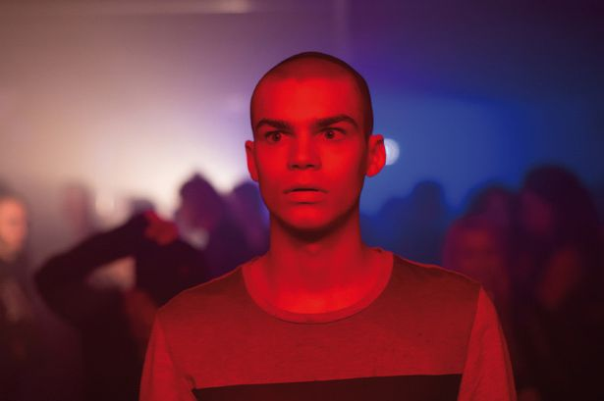What terror awaits Jakob in Nevrland? (Image: BFI)

This Austrian drama is not short of triggering and uncomfortable moments, but it will certainly last long in the memory.
Nevrland is an horrific coming-of-age tale from Austrian director Gregor Schmidinger that follows an isolated teen named Jakob (Simon Frühwirth).
Jakob is a quiet and lonely figure in the home of his father and ailing grandfather and at the meat factory where he works with his dad, cleaning down pig carcasses and having to wash the stench of death from himself every day.
One day he interacts with the mysterious Kristian (Paul Forman) on a webcam sex chat room and they endeavour to meet, but when they do a whole nightmarish trip is about to begin.
Schmidinger has certainly created a thoroughly artistic piece of work and will likely provoke strong reactions with Nevrland.
Where there can be an argument as to the film’s success at conveying its meaning, the style alone is disorienting and the atmosphere palpable.

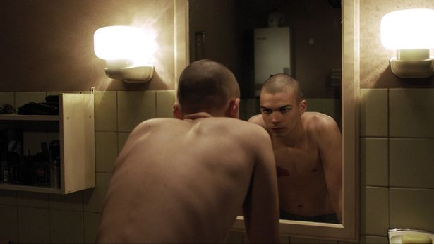
Jakob is uncertain of who he is anymore (Image: BFI)
We feel Jakob’s detached existence and longing for connection but above all else we feel his sheer anxiety at the world, at first subtle but soon in a way that feels vivid and alienating.
Frühwirth is a natural performer and radiates insecurity as Jakob, but the star is obviously Schmidinger as his direction is what dominates throughout, with hints of retro horror directors like Dario Argento and the works of Stanley Kubrick, with the rave scenes providing a colourful canvas for the young director to convey his fears.
Forman’s role as Kristian is initially interesting as an enigma but once his true intentions seem to be unveiled, he falls a little flat and proves to be no more than an attractive object of Jakob’s affections.

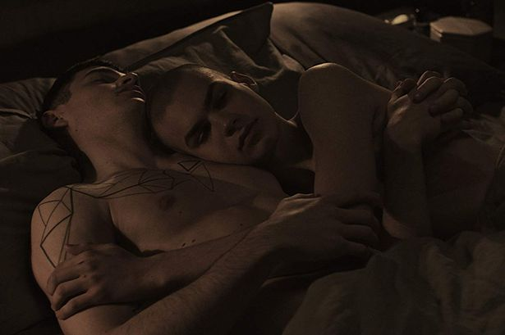
Jakob finds passion with Kristian (Image: BFI)
The mixture of heady and violent imagery with sensuality and body discovery is an hypnotic mix, but some may find the execution far too abstract and unfulfilled.
Above all else, however, is the success that Nevrland has with creating a vivid mood. So even if some might say it’s style over substance, it’s some terrific style for a burgeoning director.
With its intense aesthetic pleasures, this is one art-house horror that won't be for everyone but will surely create some conversation.

Verdict

Nevrland is a trippy nightmare of anxiety, sexuality and butchered pigs that is worth watching for style alone, albeit not for the feint-hearted.

