‘Quo Vadis, Aida?’ Review: Harrowing, Vital Retelling of the 1995 Srebrenica Massacre
A Bosnian UN translator is torn between duty and family as events tailspin toward genocide in Jasmila Zbanic's tough, compelling drama.

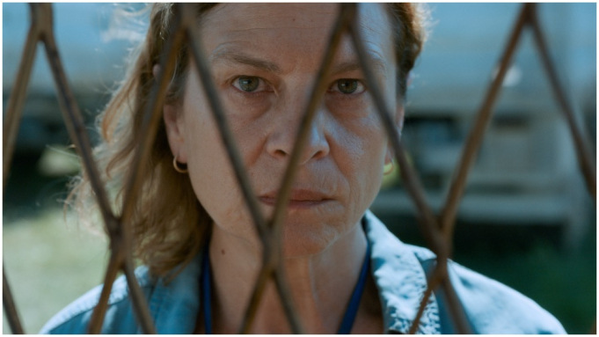
Indie Sales
Perhaps the most difficult task faced by any filmmaker attempting to commemorate an atrocity is to manage the vast disparities in scale. To communicate the extent of a war crime like the Srebrenica massacre, which saw 8,372 civilian residents of the Bosnian town, mostly men and boys, murdered by units of the Bosnian Serb Army in July of 1995, the canvas needs to be broad. But often, that scope can mean lower resolution when you zoom in, the individual human impact getting lost in the grain. But this is a perilous balance director Jasmila Žbanić (“On the Path,” 2006’s Berlin-winning “Grbavica”) achieves strikingly well in her deeply compelling, harrowing and heartbreaking “Quo Vadis, Aida?,” which reminds us that each of those 8,372 deaths is an individual, exponential multiplication of horror.
The most inspired creative decision in this sensitively fictionalized version of true events comes in the form of the film’s protagonist, Aida, a local Srebrenica resident who works at the Dutch-run UN base nearby as a translator, and is played with an absolutely convincing mixture of grit, nobility and ferocious maternal instinct by Serbian actress Jasna Đuričić. Aida’s position, straddling the bureaucracy of the UN’s enragingly ineffectual response to Serbian incursion into a town nominally under their protection, and her personal roles as wife and mother, places her at the exact nexus of institutional and individual involvement in the conflict. In some ways, her position parallels that of Zbanic, who as a filmmaker has a responsibility to contextualize the wider story, but as a Bosnian who, during the time of the massacre was living under siege in Sarajevo, also has an acute, personal stake.
Due to her “privileged” position (the UN pass that dangles around her neck takes on almost mythical importance as she is waved through barriers that determine life or death for others), Aida has unusual access to the local UN command led by the Dutch colonel Karremans (Johan Heldenbergh) and his second-in-command Franken (Raymond Thiry). Without exculpating them of personal responsibility, these men, and the other soldiers, doctors and translators who are Aida’s colleagues and friends on the UN base, are shown by Zbanic’s complex but clear-eyed screenplay, to be in an impossible situation. “We have rules here. We follow rules,” Franken tells her in response to her latest desperate negotiations on behalf of her family. But when you’re facing an enemy with no such code, does following orders issued far away for political reasons that will end the lives of thousands not become a sin all its own?
When Karremans’ superiors fail to deliver promised airstrikes, Serb forces, under Gen. Ratko Mladic (Boris Isaković), a war criminal notorious even then, roll into the town with impunity, and a column of refugees duly turns up seeking protection at the UN base. One of Aida’s sons, 17-year-old aspiring rock star Sejo (Dino Barjović) makes it to the relative safety of the overcrowded, under-resourced facility. But her school headmaster husband Nihad (Izudin Barjović) and fearful elder son Hamdija (Boris Ler) are shut out, along with thousands of others — a biblical expanse of humanity baking in the high summer heat outside the gates.
And so begins a series of escalating “Sophie’s choices” for Aida, whose job is to communicate increasingly impotent and sometimes demonstrably false, ultimately fatal UN orders to her frightened Bosnian neighbors, while also trying to extend her own UN protections to her family, to the exclusion of those others. And this is all before Mladic inevitably turns up at the base and starts ruthlessly dividing the refugees according to gender, and herding them on to transports. No one knows for sure where they are being taken, but the drivers come back looking haunted, chain smoking out of the window and avoiding everyone’s eyes.
There are ongoing debates around the aestheticization of atrocity, which recur periodically on the festival circuit as with last year’s Venice entry “The Painted Bird” or Rithy Panh’s Berlin 2020 title “Irradiated.” Zbanic avoids this trap by making a far more straightforward and unadorned film, unobtrusively but intelligently photographed by DP Christine A. Maier, yet still creating palpably intensifying drama, aided by the thriller rhythms of Jaroslaw Kominski’s editing. And taut as it is, the storytelling finds space for details that add to the film’s emotional and historical acuity: the burning of Nihad’s wartime journal; the banter of the Serbian Army troops who were Aida’s students pre-war; the way the swaggering Mladic magnanimously hands out bread and Toblerones and Coca-Cola to families he’s about to rip apart.
The Srebrenica massacre has become the subject of intense politicization, to the point of genocide denial in some quarters, to which the moral clarity of Zbanic’s film operates like a rebuke. This is not historical revisionism, if anything, “Quo Vadis, Aida?” works to un-revise history, re-centering the victims’ plight as the eye of a storm of evils — not only the massacre itself, but the broader evils of institutional failure and international indifference. Ending with an intensely moving epilogue that reads as both a slender hope for a co-operative future and a cry of anguish for survivors who even now must live alongside those perpetrators never brought to justice, this is a fiercely impressive recreation of impossible dilemmas that should never have arisen, a situation that never should have happened and a human catastrophe that must never be forgotten.

Reviewed at Venice Film Festival, Sept. 3, 2020. Running time: 103 MIN.
- Production: (Bosnia Herzegovina-Austria-Romania-Netherlands-Germany-Poland-France-Norway-Turkey) A Deblokada production, in co-production with Filmproduktion, Digital Cube, N279, Razor Film, Extreme Emotions, Indie Prod, Torden Film, TRT, ZDF ARTE. (Int'l Sales: Indie Sales, Paris.) Producers: Damir Ibrahimovic, Jasmila Zbanic.
- Crew: Director, writer: Jasmila Žbanić. Camera: Christine A. Maier. Editor: Jaroslaw Kominski. Music: Antoni Komasa-Lazarkiewicz.
- With: Jasna Đuričić, Izudin Bajrović, Boris Ler, Dino Bajrović, Boris Isaković. (Bosnian, English, Dutch dialogue)

