Berlin Film Review: ‘The Ground Beneath My Feet’

A high-performing consultant finds her life unraveling as she maintains a professional façade while supporting her schizophrenic sister.By Jessica Kiang 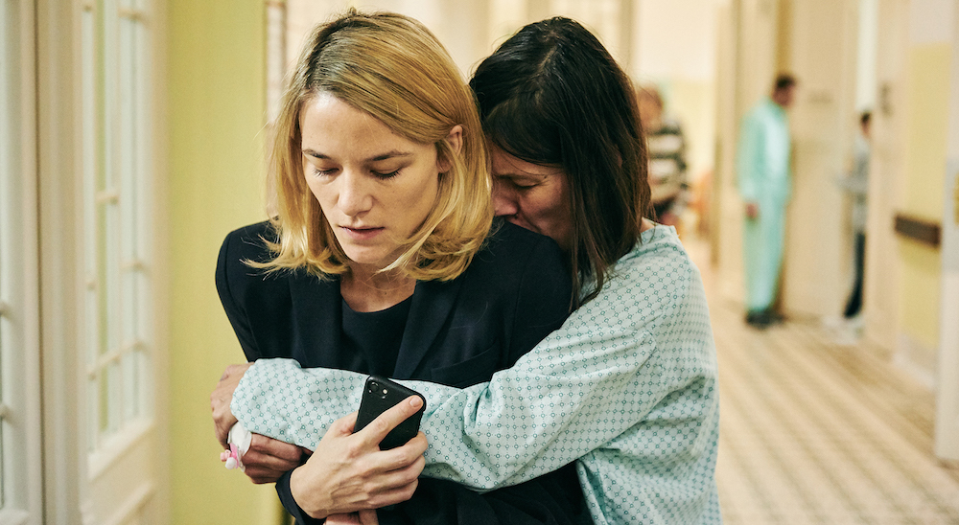
CREDIT: Juhani Zebra

Director:
Marie Kreutzer
With:
Valerie Pachner, Pia Hierzegger, Mavie Hörbiger, Michelle Barthel, Marc Benjamin, Axel Sichrovsky, Dominic Marcus Singer, Meo Wulf. (German dialogue)
1 hour 48 minutes
Lola (Valerie Pachner) wakes with a start. She has what we’ll soon learn is an uncharacteristic smudge of mascara beneath her too-bright, too-awake eyes. But then this is the Lola of later, not the woman to whom Marie Kreutzer’s nervy, nuanced drama “The Ground Beneath My Feet” first introduces us — not the ambitious, high-performance business consultant, whose only respite from a grueling, high-heels-and-rolling-suitcase lifestyle appears to be a similarly grueling workout regime. Whether sweating ferociously in some anonymous hotel gym, prepping for a 48-hour workday with a morning jog or burning the midnight oil over spreadsheets and data analysis, the ground beneath Lola’s feet is a treadmill.
The absolute order of her life, compartmentalized right down to the borderline psychotic neatness of her underwear drawer, conceals a messy secret: Lola’s older sister, Conny (Pia Hierzegger) is a paranoid schizophrenic who has been hospitalized following a suicide attempt that Lola insists unconvincingly was an accidental overdose. For a time, Lola maintains her impervious professional front, concealing her real whereabouts from her colleagues and her boss Elise (Mavie Hörbiger) with whom she is having an affair, as she flies back and forth between work in Rostock and Conny’s institution, and her own rarely-lived-in home, in Vienna. But then, to her understated terror, she starts to suspect her own grip on reality may be faltering. Paranoia is largely the absolute absence of trust, after all, and one quality that the cutthroat job Lola does so well requires is the belief that trust is a liability.
This is a fertile, if slightly familiar, thriller setup, ripe with the potential for unreliable narration, doppelganger switcheroos, and maybe even entirely invented personas. In the production notes, Kreutzer herself mentions “Marnie” as an inspiration, and while Lola insists, “You would never know we’re sisters,” when she finally confesses her secret, the two actresses bear enough physical similarity that there are also faint echoes of the Judy/Madeleine dichotomy from “Vertigo.” It feels cunningly engineered to make us wonder if perhaps Lola’s self-discipline is not so much a character trait as a stringently monitored act of self-creation, an impression enhanced during a late scene at the salon when Lola, perhaps naturally a brunette like her sister, gets her hair lightened back to Hitchcockian blondeness.
But though not without some gothic, noirish elements — creepy phone calls and malfunctioning elevators — “The Ground Beneath My Feet” is not really a thriller at all. Kreutzer, making a leap up in scope and accomplishment from 2016’s generational snapshot “We Used to Be Cool,” approaches her potentially sensationalist storyline with level-headed realism and her interest in exploring schizophrenia itself rather than using it as a driver for some disposable final plot twist is refreshing. This embrace of messy, compromised ambivalence over cathartic narrative revelation may frustrate those looking for a more full-throated thriller denouement, but it gives Kreutzer’s film a depth of insight that is rare in the cinematic treatment of this most misunderstood of diseases.
In fact, as though in an effort to rein in the story’s gaudier tendencies, the filmmaking can feel restrained to the point of constrained, particularly in the slightly repetitive third act. The expressive potential of Leena Kopper’s discreet camerawork is a little hampered by the deliberate anonymity of Martin Reiter’s production design, which eloquently makes the point that, in terms of institutional sterility, Lola’s hotel bedrooms and corporate boardrooms are remarkably similar to Conny’s hospital wards and corridors, prompting us to wonder just which of the two is the more imprisoned. But the lack of visual variety does start to wear toward the end, and with Kyrre Kvam’s unobtrusive score only sparingly used, the already anticlimactic finale threatens to become a little pallid.
Pachner’s riveting performance, which earns our sympathy without ever courting it, is fine compensation however. And it’s as a portrait of an alpha-female lifestyle undermined by mental instability that the film makes its most valuable contribution to cultural conversation around gender expectations and mental health in professional environments. When a sleazy client makes a crude suggestion to Lola over dinner with no one around to witness it, it’s possible she imagined it. But it’s just as possible she did not, and while the heteronormative, often sexist assumptions made by colleagues and doctors and department store staff go unchallenged, the broader implication of these moments is subtly communicated: Women in public spaces are frequently playing a social role that bears little relation to their actual personalities.
Without proselytizing, and without distracting from the main thrust of her gripping, intelligent psychodrama, Kreutzer and her predominately female team have created a story both knottily specific and usefully general in its understanding that for many women, an ultimately untenable level of watchful self-control is the price of ambition, as inescapable and treacherous as the uneven ground beneath our feet.
Berlin Film Review: 'The Ground Beneath My Feet'
Reviewed at Berlin Film Festival (competing), Feb. 9, 2019. Running time: 108 MIN. (Original title: "Der Boden unter den Füßen")
Production: (Austria) A Novotny & Novotny Filmproduktion production, with the support of the Austrian Film Institute, Vienna Film Fund, Film Industry Support Austria, in collaboration with ORF Film/Television‐Agreement. (Int'l Sales: Picture Tree International, Berlin.) Producers: Alexander Glehr, Franz Novotny.
Crew: Director, screenplay: Marie Kreutzer. Camera (color, widescreen): Leena Kopper. Editor: Ulrike Kofler. Music: Kyrre Kvam.
With: Valerie Pachner, Pia Hierzegger, Mavie Hörbiger, Michelle Barthel, Marc Benjamin, Axel Sichrovsky, Dominic Marcus Singer, Meo Wulf. (German dialogue)

